Flink Concepts

Kuberneties Architehture

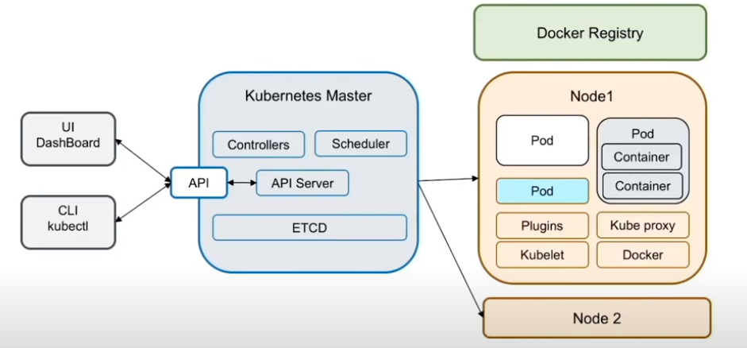

Config map : is dictionary of configuration settings .This dictionary consist of key value pair of strings

Service : Is an abstract way to expose and application running on a set of pods as a network service

Pod : Smallest deployable unit ,consist of one or more containers

Deployment : is a higher-level abstraction to manage set of identical pods

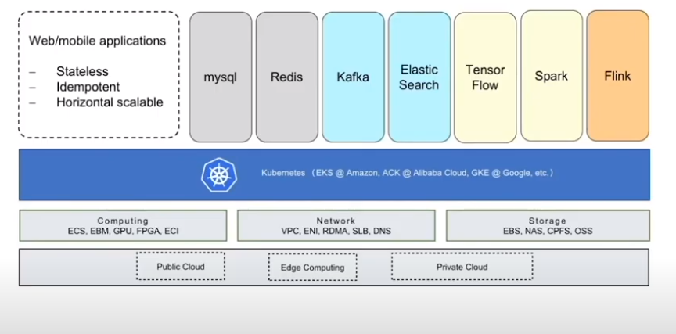

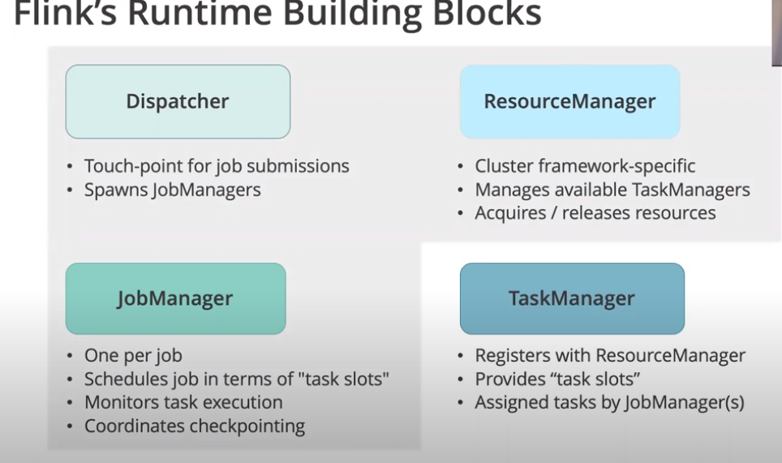

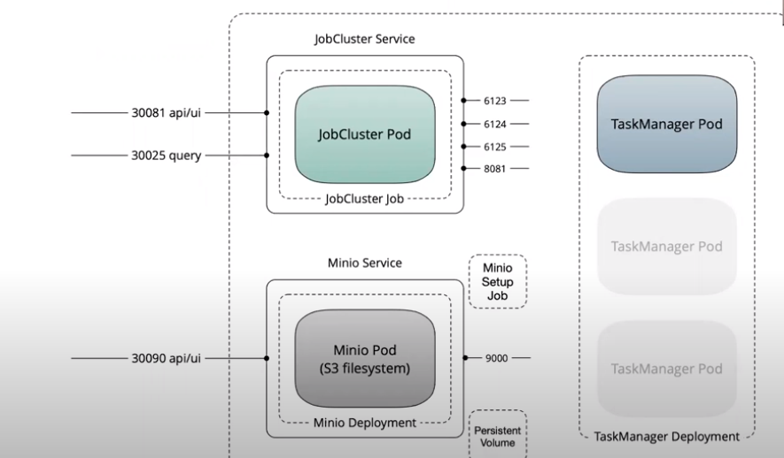

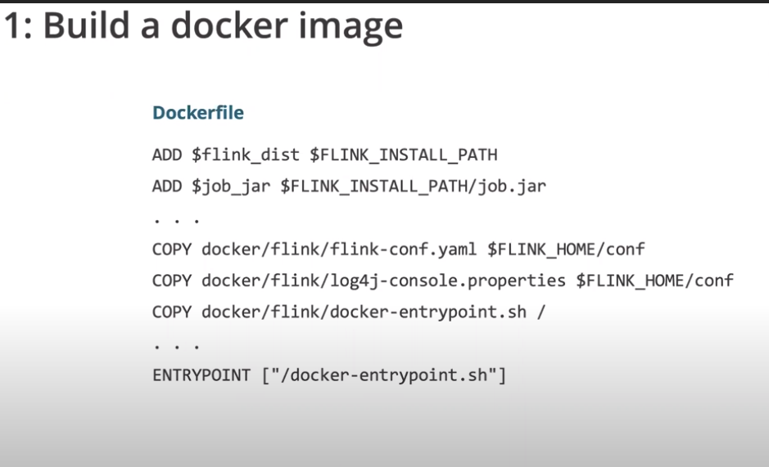

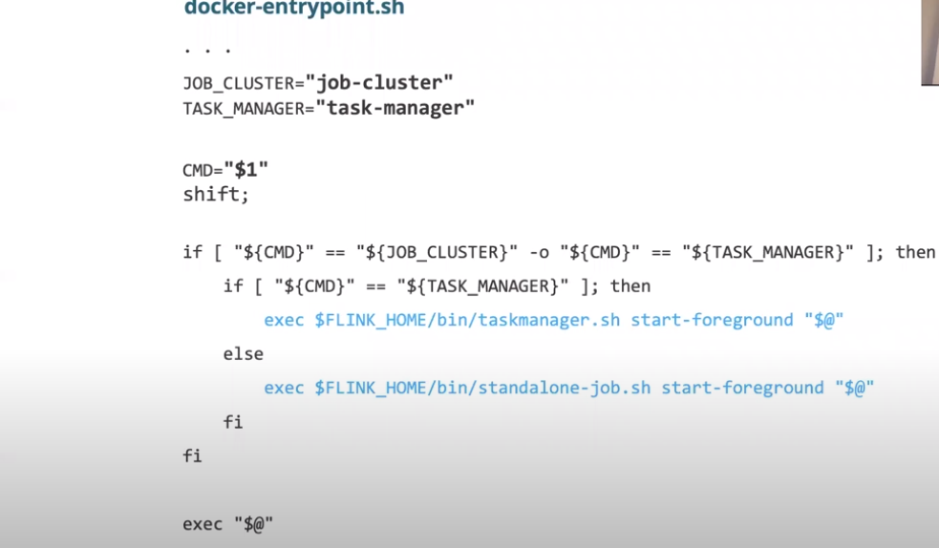

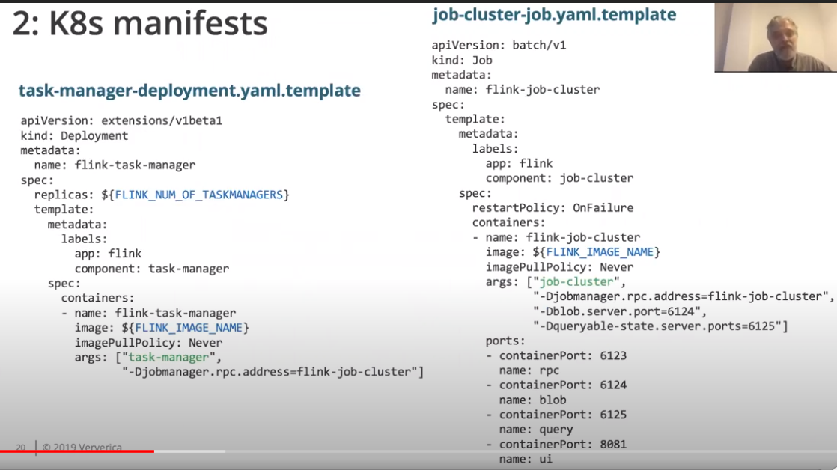

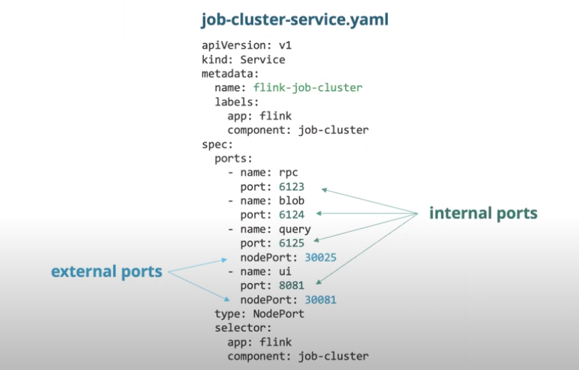

./docker/flink/build.sh --job-jar target/streaming-job-*.jar --from-archive ~/flink-1.14.3-bin-scala_2.11.tgz --image-name streaming.job:latest

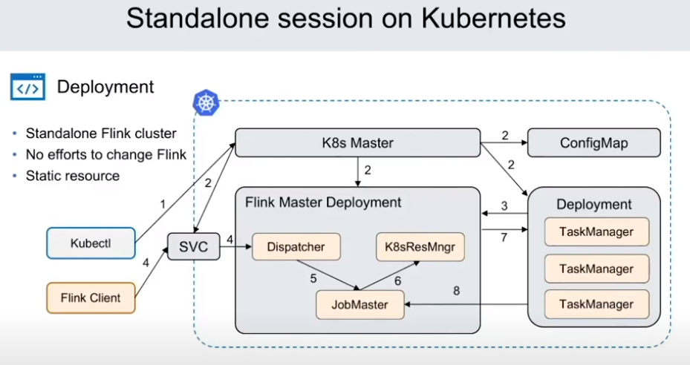

Manually requires to scale task managers

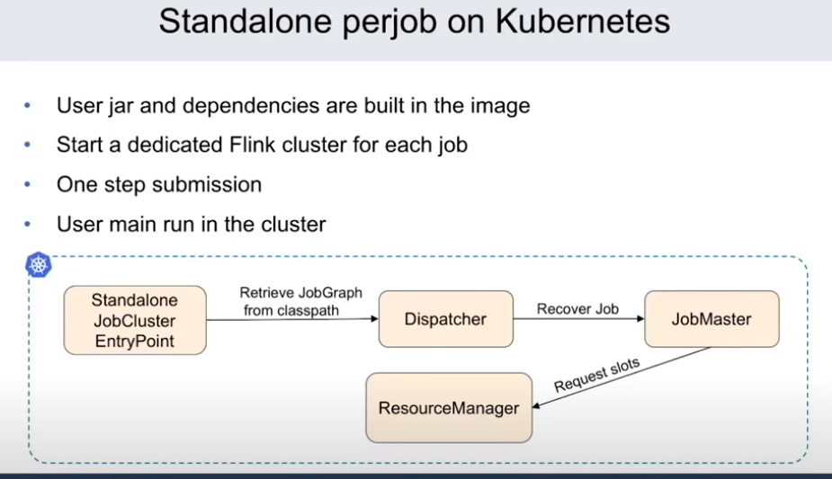

Kuberneties Native means

Self Container

Embeded K8 client inside

Do not need external tools to start/stop flink cluster

Flink Client natively contact Kuerneties api server to create JoManager

Flink resource Manager natively contact Kubernetes to create Task Manager Pod on Demand

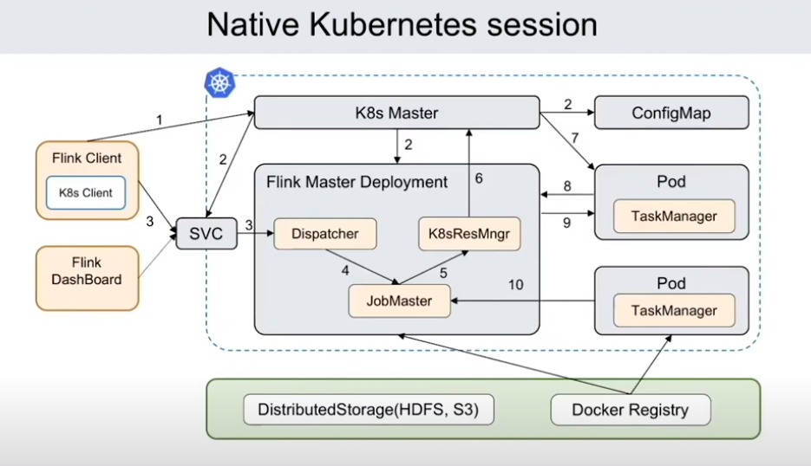

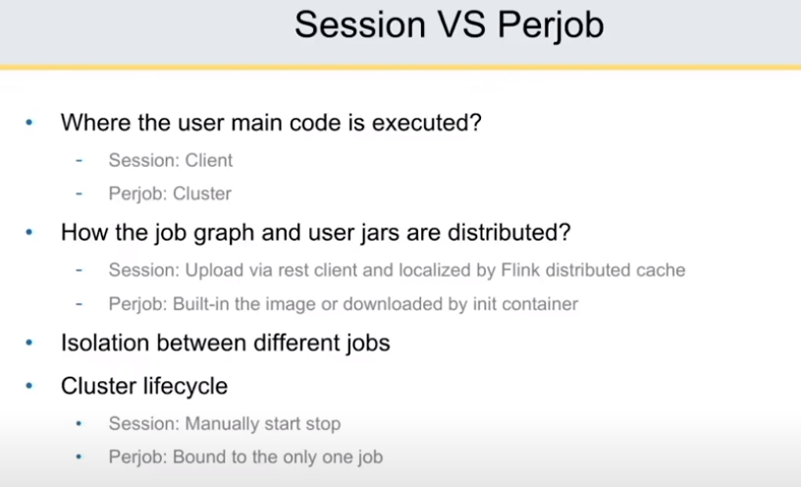

Session

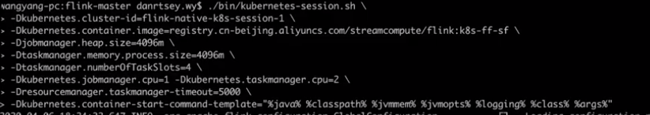



Per job session

